**Customizing the OpenHDS data model for various project sites**

**Physical Data Extensions**

The Data Extensions module is built to perform Physical Data Extensions. The Data Extension module can be used to add Physical Extensions without modifying any source code. It provides a user interface to define the entity type the extension is for (i.e. individual, location, social group, visit), attribute type (any of the primitives), name of the attribute, and constraints.

* Double click the **dataextensions.jar** located in **openhds-core/dataextensions**
* Proceed to the Extension tab and fill out the form like the following:

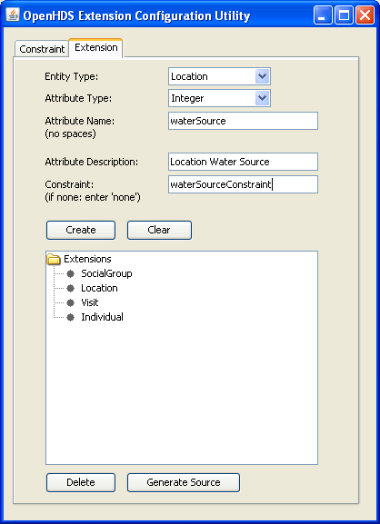

In this example, a new water source attribute will be created for the Location entity. It's defined to be an 'integer' type and has a 'waterSourceConstraint' specified as its constraint.

* Press the 'Create' button, the extension will now be added to the window below.
* Proceed to the Constraint tab and fill out the form like the following:

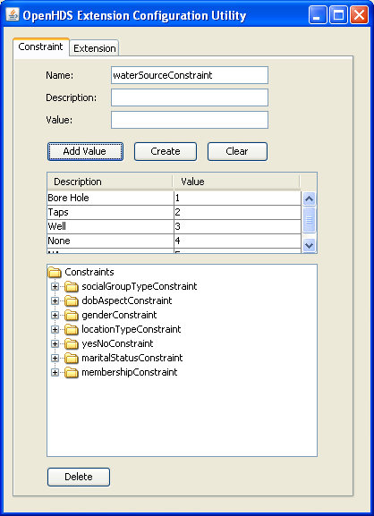

In this example, the 'waterSourceConstraint' is defined. It will restrict the values of the waterSource attribute defined earlier to the values 1 through 5.

* Press the 'Create' button to add the constraint to the window below.
* Proceed back to the Extension tab and press the 'Generate Source' button. This will add the new attribute to the Location entity.

Note

Now that the attribute has been successfully added to the Location table, that attribute must now be linked to the web form. There is not an automatic mechanism in place that allows attributes added by Physical Data Extensions to be linked to the web forms. Attributes must be added to the web forms manually. There is a recommended workflow that project investigators can follow to perform this task which doesn’t require much technical experience. To do this linking, the web forms will need to be modified. The Web module contains web forms for each of the core entities in the system. The location web forms consist of create, edit, detail, and list .xhtml files

* Modify the create, edit, detail and list .xhtml files located in **openhds-core\web\src\main\webapp\location** by adding the following snippet

<h:outputText value="Water Source:"/> <h:inputText id="waterSource" value="#{locationCrud.item.watersource}"/>

This snippet prints a label along with a text field that binds the value to the backing entity object. Adding this snippet is the only requirement for linking attributes with no constraints.

* Rebuild the OpenHDS by executing **mvn clean install** from the root folder and deploy the application.
* Proceed to the Location form, which will look like the following:

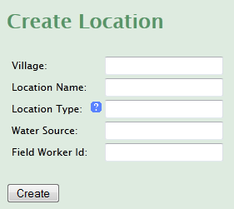

he OpenHDS provides special user interface widgets for attributes that have constraints associated with them. The water source attribute defined previously had many constraints applied to it but there is no indication of those constraints on the web form. It’s not reasonable for a user of the application to remember that entering a value of ‘1’ means that it’s a ‘Bore Hole’.

* Add the widget to display constraints for attributes by adding the following snippet to each one of the location entity .xhtml files.

<h:outputText value="Water Source:"/> <img class="clickable" onclick="O$('popupWindowForWaterSource').showCentered();" src="#{request.contextPath}/resources/images/question.png" /> <h:inputText id="watersource" value="#{locationCrud.item.watersource}" converter="#{defaultConverter}" />

* The final modification involves adding a new snippet to the **default.xhtml** file located in **openhds-core\web\src\main\webapp\templates**

```

**Valid Values:h3>**

* **#{dv.key} - #{dv.value}**

```

* Redeploy the OpenHDS and proceed to the Location form. The newly added attribute with it's defined constraints are now viewable.

